Assignment 2: Group Project – Build A Web Application

A coversheet with the names and student numbers of all team members

Student Name 1_________________________ Student Number 1_____________________________
Student Name 2_________________________ Student Number 2_____________________________
Student Name 3_________________________ Student Number 3_____________________________
Name of Web Application______________________________________________________________

A brief overview of the website, including a list of the pages which you will create.
List of standard pages you will create
List any administrative pages that you think you might like to include. And state their proposed function
- Page 1
- Page 2
- Page 3 – Be able to create new pages
- Etc.

2.1 User Groups and Permissions
Make any change you feel appropriate to the section below
- User Groups
  - Public
  - Member
  - Admin
- 5 basic pages
  - Cannot be deleted by the admin.
  - Can be modified by the admin (title, text and images)
- Additional pages
  - Can be created/deleted/edited by admin.

2.2 Inspired by
- Identify 3 websites that you would like to draw design inspiration from and say what factors you would like to incorporate from each of them
  - Site 1
  - Site 2
  - Site 3

2.3 Site Map
Include a site map showing how the pages specified in the wireframe section link together and a few sentences of explanation. I have I included this a sample.
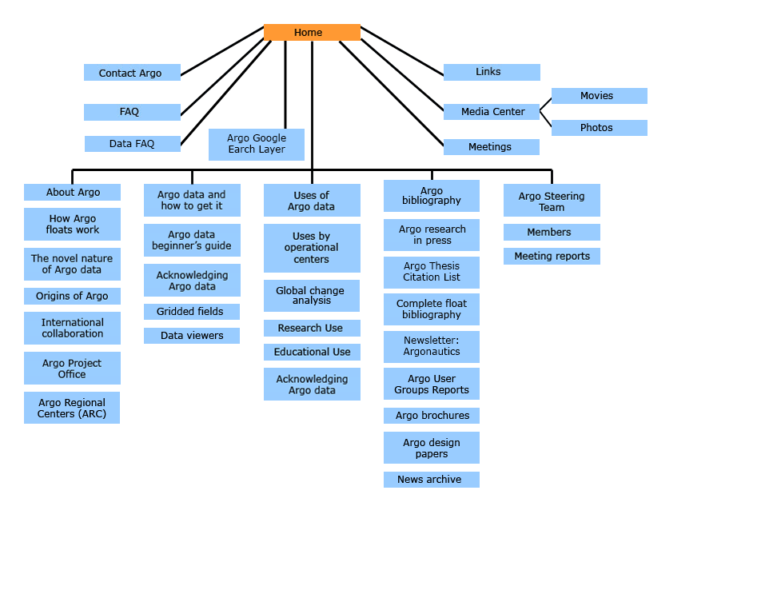

Wireframes of key pages the website (5 pages)

Include a wireframe for each of the pages listed below and a few lines of explanation. Ensure that each page meets the requirements as indicated in the description document.

Home

Registration

Class

Testimonial

Contact Us

Administrative Pages (2 examples)

Extra features and improvements (max. 2 pages)

You may include images in this section if you so wish, it is not essential.
- Feature 1 Name: Details of the feature.
- Feature 1 Name: Details of the feature.

Database design – ERD: tables and relationships

An example ERD has not be included but tables that you may wish to include are
- user
- registration
- class
- testimonal
- contact_us
- page
- fee
- Etc.
You will need to change all m:n relatiosnships to 1:m, n:1 relationships.

